**ISYS6256 – INFORMATION SYSTEM PROJECT MANAGEMENT**

**ANDRI IRWANDI – 2201743131 – LO11**

1. Brief description of my IT project

So my IT project was to implement CRM or Customer Relationship Model in the Jasakom solution company. Jasakom Solution is engaged in hardware service such as printers, CPUs and other computer devices. Jasakom Solution is located in modernland.

The problem with Jasakom Solution is that it is difficult to achieve and maintain leadership and profitability. It is difficult for Jasakom Solution to maintain customer loyalty because there is a lot of competition with companies engaged in hardware service as well

So I will implement CRM or customer relationship model to find out what customers need edfrom Jasakom Solution, and the behavior of customers who are expected to improve performance and improve relationships with customers so that Jasakom Solution can be more advanced by implementing Customer Relationship Model and to advance profits and work prospects of Jasakom Solution.

1. Part of project risk management
2. Possible risks of my project
3. The CRM initiative was not carefully though out and planned Analyze the risk
4. Budget estimates are to low
5. Stakeholder demand additional scope
6. Key team project leaved the project
7. Quality of the services does not meet expectations
8. The implementation of CRM late
9. Client unable to define scope and requirements
10. Business processes and workflow are not properly defined
11. Quality of data is inacccurate, not available accross different format
12. The implementation of CRM may take longer time than expected
13. Error strategy on implementation CRM
14. Poor implementation and process problems
15. Fail to produce results consistent with project specifications.
16. Sufficient resources
17. Analyze the risk

(I create my project risk with microsoft Excell)

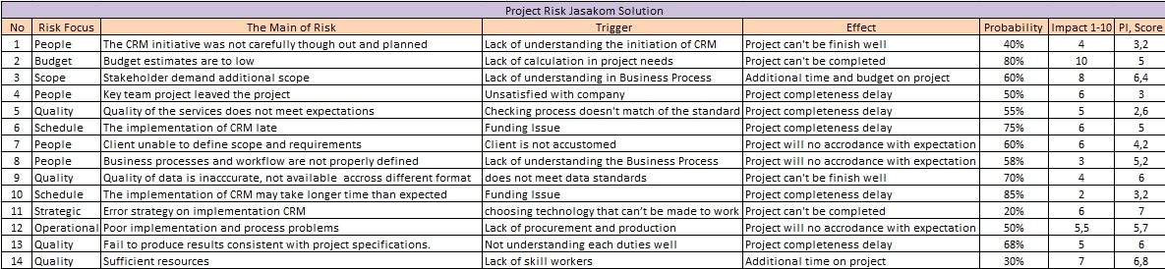

1. Risk strategies of my project by

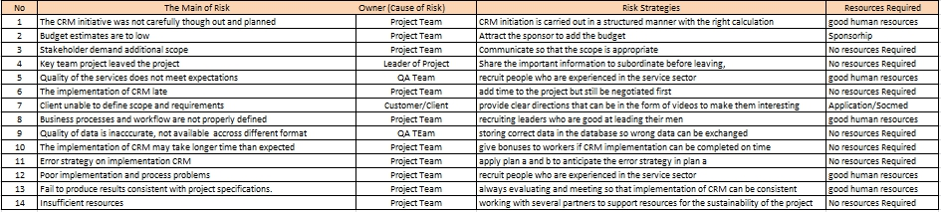

Risk Strategies of implementing CRM on Jasakom Solution :

--)Determine the processes, channels, and organizational units

-Communication and sales channels

-Customer Segments

-Services

-Organizational Units

--) Set clear and Measurable goals

-Sales and Marketing, product development, process efficiency, business strategy, customer

Satisfication.

--) Recognize and set an efficient data model

Where the data was stored and the quality is. Want to migrate all or just certain the data.

1. Quality metrics for my project

So, i will create Cost Metric, Schedule Metric, quality metric and company metric

To creating cost metric and schedule metric, planned, actual & Earned values was needed.

Note : i create this for 1 month

-Planned, Actual & Earned Valued of Jasakom Solution for 1 Month

|  |  |  |  |
| --- | --- | --- | --- |
| Task | Planned Value | Actual Value | Earned Value |
| Evaluate the current technology platform | $2.000 | $4.000 | $2.000 |
| Define user requiremets | $1.000 | $3.000 | $2.000 |
| Test the product function (CRM) | $2.000 | $2.000 | $3.000 |
| Train Users | $3.000 | $1.000 | $1.000 |
| Write report to the management | $4.000 |  |  |
| **Cumulative** | $12.000 | $10.000 | $8.000 |

Planned value = $12.000 (what we planned to pay)

Actual value = $10.000 (what we have to pay)

Earned Value = $8.000 (what we should to pay)

1. Cost Metrics

Cost Variance(CV) – the difference between task’s or WBS component estimated cost and its actual cost.

CV = negative value – over budget

Positive value – under budget

Value = 0 means project is right on budget

Cost Performance Index (CPI) - percentage of work completed per dollar spent

CPI = ratio > 1 – ahead of budget

Ratio < 1 – behind budget

Ratio = 1 means project is right on budget

CV : Cost Variance

CPI : Cost Performance Index

EV : Earned Value

AC : Actual Value

CV = EV – AC

= $8.000 - $10.000

= ($2.000) is a negative. Negative means the project is over budget.

CPI = EV/AC

= $8.000/$10.000

= $0,8 (Project is over budget)

Conclusion = Implementation Customer Relationship Management on Jasakom Solution was over budget.

1. Schedule Metrics

Schedule Variance (SV) – the difference between the current progress of the project.

SV = EV – PV

Negative Value = behind schedule

Positive value = ahead of schedule

Value 0 = Means project is right on schedule

Schedule Performance Index (SPI) – a ratio of the work performanced to the work shcedule.

SPI = EV/PV

Ratio < 1 = Ahead of schedule

Ratio > 1 = behind schedule

Ratio =1 = Project is right on schedule

SV = EV – PV

= $8.000 - $12.000

= ($4.000) means project is behind schedule.

SPI = EV/PV

= $8.000/$12.000

= $0,67 means the project is behind schedule

Conclusion = Impementation Customer relationship management on Jasakom Solution was behind schedule.

Schedule metric and cost metric template got from ISPM binus university power point 19-20.

1. Project Performance Metrics

Project performance metrics is related to schdule metrics and cost metrics.

|  |  |  |  |  |  |  |  |
| --- | --- | --- | --- | --- | --- | --- | --- |
| Task | (PV) | (AC) | (EV) | (CV) | (SV) | (CPI) | (SPI) |
| Evaluate the current technology platform | $2.000 | $4.000 | $2.000 |  |  |  |  |
| Define user requiremets | $1.000 | $3.000 | $2.000 |  |  |  |  |
| Test the product function (CRM) | $2.000 | $2.000 | $3.000 |  |  |  |  |
| Train Users | $3.000 | $1.000 | $1.000 |  |  |  |  |
| Write report to the management | $4.000 |  |  |  |  |  |  |
| Cumulative | $12.000 | $10.000 | $8.000 | ($2.000) | ($4.000) | $0,8 | $0,67 |

1. Project Metrics

|  |  |  |
| --- | --- | --- |
| Type | Metric | Description |
| Process | Defect Arrival Rate | The number of defects found over a specific period of time |
|  | Defect by Phase | The number of defects found during each phase of the metrics |
|  | Defect Backlog | The number of defects waiting to be fixed |
|  | Fix Responsive Time | The average time it takes to fix a defect |
|  | Defective Fixes | The number of fixes that created new defects |
| Product | Mean time to failure | Average or mean time elapsed until a product fails |
|  | Defect Density | The number of defects per lines of code or function |
|  | Customer Found Defects | The number of defects found by the customer |
|  | Customer Satisfication | An index to measure customer satisfication |
| Project | Scope Change request | The number of scope changes requested by client or sponsor |
|  | Scope change approval | The number of scope changes that were approved |
|  | Over due tasks | The number of tasks that were started but not finished by the expected time |
|  | Tasks that should have started | The number of task that should have started but have been delayed |
|  | Over budget task | The number of task that have cost more to complete than expected |
|  | Earned Value | SV, CV, SPI, CPI |
|  | Over allocated Resources | The number of resources assigned to more than one task |
|  | Training | The number of training hours of project members |

Information System Project Management textbook

(<https://binusmaya.binus.ac.id/newStudent/?#/textbook/view.9781119128441/0>)

1. Project Communication

|  |  |  |  |  |
| --- | --- | --- | --- | --- |
| Stakeholder | Reporting  Requirements | Reports/Metric | Reason | Format |
| Management | During periodic intervals **Time Frame :**  Giving a weekly to help the team member benefit from it. | Current activities reporting, what to do list | Management will enhanced customer experience leading to improve top-line of CRM on Jasakom Solution, Reduced total cost of Operations resulting in improved bottom-line, Improved business reporting leading to better governance, company branding through improved customer services. | Face to face meeting |
| Marketing Managers | During periodic review meeting. **Time Frame :**  The report will be send every once a week . | Earned value reporting | Marketing Managers send the report every once a week because Jasakom Solution must know development of the project.  Marketing managers will correct customer of Jasakom Solution based on various parameter, effective tracking of marketing budget, use of appropriate treatment for marketing campaign based on customer segment, and event planning for Jasakom Solution | E-mail on PDF |
| Retail Sales Agent | During periodic of time **Time Frame :** The report will be sent every month | Sales report, report of the agenda of the sales agent | Retail sales agent will ease of navigation the processes of implementing CRM on jasakom solution, validation to prevent duplication of data, accurate calculation of incentives | E-mail on PDF |
| Sponsorhip | During periodic review meetings **Time Frame :**  Considering project with 2 months of duration | Project summary, budget | The report will show the baseline schedule of implementing CRM on Jasakom Solution.  Sponsorhip will facility to search the hardware on Jasakom Solution and services, frequent status update, see all the charges associated with product and sevices, | Paper Reports |
| Dealers | During periodic of time **Time Frame :** Giving the report 3 times on the project timeat the beginning, middle and at the end. | Slipping tasks and milestone | Dealers will self care fungtionality of CRM, sharing of opportunities to and from Jasakom Solution, accurate calculation, automatic accrual and quick redemtion of loyalty points | Paper Reports |
| Project Managers | At periodic intervals **Time Frame :** This report can be sent to the project manager once a week | Earned Value, project summary, slipping tasks, critical tasks, milestone and resources | Report must be sent once a week from the project managers because its important as a managers that handle many part of implementing the CRM system on Jasakom Solution  Project Managers will to reduced time to market, facility to bundle, introduction of availability, facility to attach users manuals, facility to quickly introduce product of Jasakom Solution without products without technical involvement | face to face meeting |

Resources template from ISPM E-Textbook page 209 figure 8.2

Link of the textbook

(<https://binusmaya.binus.ac.id/newStudent/?#/textbook/view.9781119128441/1>)

1. Which approach that will i adopt for users/employees of the orgranization.

I will approach the Enviromental Adaptive strategy. Why ? Because, The Environmental Adaptive strategy uses the adaptive nature of the people. generally people don’t like loss and instead of trying to change the people you can build another organization and shift people there so that they work in the new environment according to the new rules. On Jasakom Solution projected on implementing an CRM or Customer Relationship Management that as we known an new system or a new project on Jasakom Solution, Jasakom Solution creating an new organization with a new project team and of course when there is a new system, there is a new rules too.

1. System implementation that will i approach

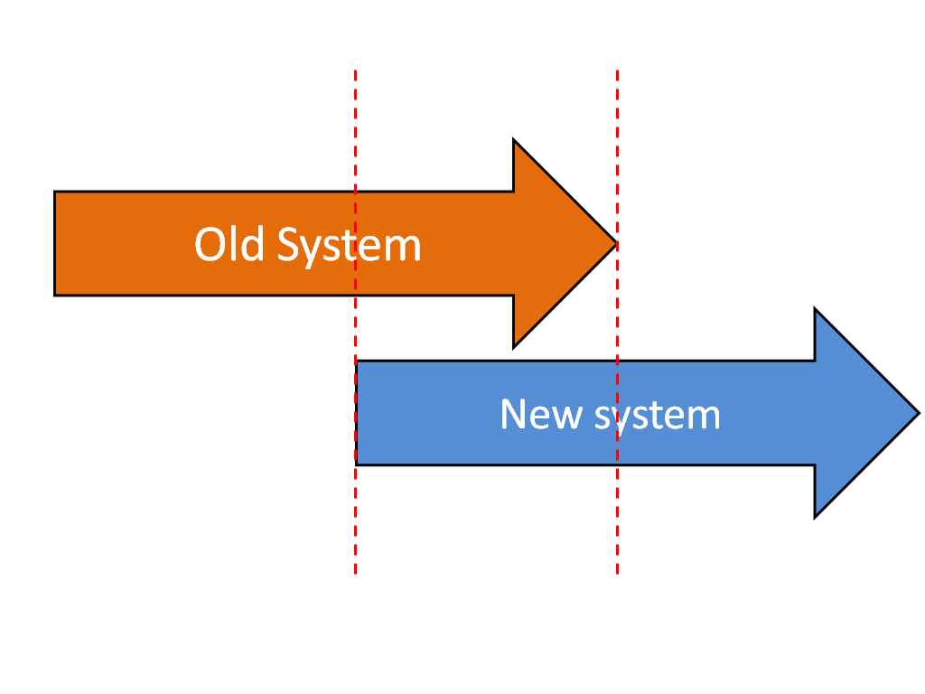

Image link :

(<https://www.google.com/url?sa=i&url=https%3A%2F%2Fen.wikipedia.org%2Fwiki%2FParallel_running&psig=AOvVaw06ZRX2LAVKEk4awiBPmldJ&ust=1593102264602000&source=images&cd=vfe&ved=0CAIQjRxqFwoTCLCuz-XumuoCFQAAAAAdAAAAABAD>)

I will choose Parallel implementation on implement Jasakom Solution new CRM or Customer Relationship Management.

There are the risk of implementing parallel implementation, such as :

* Take longer and require more resources than direct.
* Places more pressure on the users.

But in my opinion, parallel implementation is the most safety on implement new CRM for Jasakom Solution. Parallel running allows result to be compared to ensure that the new system (Customer Relationship Model) is working well on Jasakom Solution. If error are found, Jasakom Solution can refer to the old system to resolve the problem and make the modifications to the new system (Csutomer Relationship Model) thus operation can continue under the old system while the problem are sorted out.

Implementing parallel system also train the staff on Jasakom Solution and adapt on the new system (CRM) from the old system.

Youtube link video : <https://youtu.be/Ob7tUjUz-EY>